**Basics of Docker**

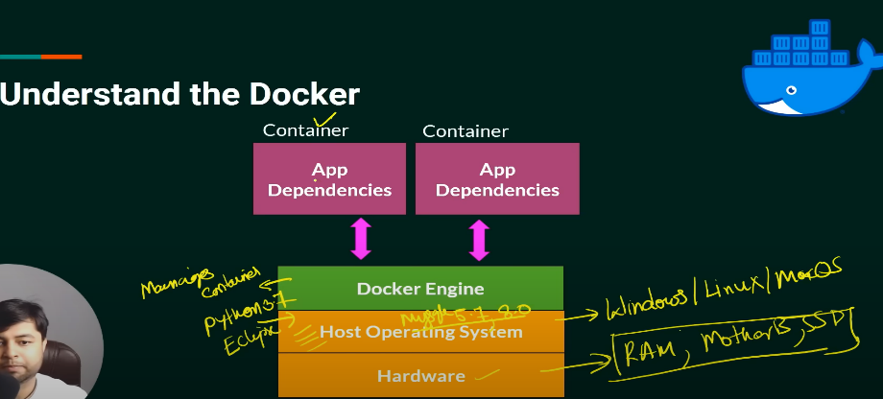

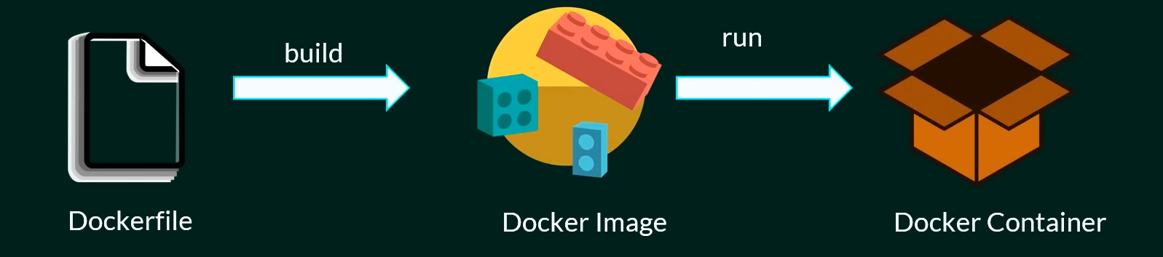

1. docker images -> Use to see all images
2. docker pull imageName or docker pull imageName : versionName - > docker image pull from docker hub
3. docker run imageName or id -> to run images.
4. docker search mysql -> to search image then it'll show the list of availble images.
5. docker ps -> to see see container
6. docker ps -a -> to see all container
7. suppose aapke docker ka jo container uska console access karna hai

docker run (yaha alag alag flag pas kar sakte hai) like docker run --env ,-e,-detach ( Detach) ,-d

where detach is option to run a container hai

eg -: docker run --name pythonContainer -d 63490c269128

1. docker run --name pythonContainer1 -it -d pyhton -> run container in intractive way so we can watch container at run time

aur ye container band nhi hoga ab ham iske andar bhi ja sakte hai

1. docker exec -it 1871ef077c3e python3 -> container ke andar jane ke liye

or docker exec -it containerID then chose which cmd want to run.

1. docker inspect 1871ef077c3e(container ID) -> docker container ki information dekhni hai toh .
2. docker exec -it javaContainer(container name or id) jshell(command name)-> To access running container.

Now we are inside java container we can use all cmd of java

to exit from here type -> /exit

1. docker stop xyz(container name or id) -> To stop image

eg : docker stop pythoncontainer1

1. docker rm containerId -> to remove the containerwe can remove all the container together like this eg: docker rm 32609038ed40 6ca5c869c575 42f5b96cd335 27facff7b0d1 4a5c4be5dee6 2103b8efed3a 88f46e1d15a5
2. docker rmi 948c85e875fa -> to remove images form docker
3. to push ur images in docker hub you have to login first through Docker login
4. docker commit to save a img
5. docker push -> push your cmd to docker hub
6. docker copy -> copy
7. docker logs ->to see logs
8. docker volume -> it create volumes so that docker container store the data
9. docker logout -> to logout from docker hub
10. Get started with creating your own docker file
11. make new folder into your docker workspace
12. then open this at vs code using cmd and code
13. make a new file named as Dockerfile

Eg 1. FROM ubuntudocker build -t myUbuntuImage .

MAINTAINER Ritesh

RUN apt update

CMD [ "echo","this is my first ubuntu image" ]

1. docker build -t myUbuntuImage -> To build this image
2. Explanation of docker file ->

# this is base image

FROM ubuntu

# Author name

MAINTAINER Ritesh

# update command

RUN apt update

# startup excutable command

CMD [ "echo","this is my first ubuntu image" ]

1. to run a spring boot project image we need to expose the port
2. Eg-: docker run --name springbootproject -it -p 9090:9090 -d springbootimage
3. Docker file eg:

FROM openjdk

WORKDIR /user/src/myapp

COPY . /user/src/myapp/

CMD [ "java","-jar","DockerDemo-0.0.1-SNAPSHOT.jar" ]

EXPOSE 9090